CONTACTS:

MANHATTAN LIFE:
Agent Support: 888-441-0770
email: marketingmail@manhattanlife.com
Customer Service: 800-999-2971
Training Link: https://www.velapoint.com/ml-training-video/
HST Agency Administrative, Underwriting, billing, etc. support
Shaun Dillon (800)-669-9030 Ext.6536
Member services: 800-999-2971
Tech support: 888-441-0770
email: marketingmail@manhattanlife.com
Todd Hayden
Senior Vice President
Chief Marketing Officer

VIVA LIFE:
Customer Service: 800-877-7705
App Fax: 713-821-6463
Claims Fax: 713-583-8508
PHS Fax: 713-821-6573
--------------------------------------------------------------------
Manhattan Insurance Group SM
10777 Northwest Freeway, Houston, TX 77092
Email: Todd.Hayden@ManhattanLife.com
Office: 713-821-6514, 800-669-9030 ext 6514
Mobile: 413-214-5190
Online: www.ManhattanLife.com

Other ML FAQs

- I received a Welcome Letter…what does that mean? This has important information containing your agent number and instructions on how to access our website where you’ll be able to access information pertaining to the business you write. IMPORTANT: This also contains your link which allows you to write business via our electronic enrollment platform.

- How do I register? With your agent number in hand, you can access our website at www.manhattanlife.com. To register you will click on the “Agents” tab and scroll down to Agent Login and then “new users click here to register” and follow the instructions to have full website access. Also we have added a new feature to our website. You now have accessibility to your online enrollment link directly from our website; once you have logged in you will click on the Agent Tools tab, and then click on Enrollment Links, here you have the option to enroll from this page or you can copy and paste the link directly into your browser.

- How long does it take to process new business? Generally, it takes 3-5 business days but can vary depending on the product.

- Is this Guaranteed Issue? If an applicant had a Health Access plan in force and for more than the prior 12 months we will give credit for time served and issue the policy. Proof of coverage is required. Coverage must be similar to the policy that is being vacated. If it is a new applicant then normal underwriting procedures are followed.

- I have someone that had another carrier’s Limited Benefit plan. Will that qualify for credit for time served? No, Unless it’s Assurant Health Access. That policy needs the Underwriting questions answered.

- Who can I speak with about commission questions? Your up line can handle any commission inquiries.

- Can you stay on the phone with me while I walk through the online contracting process? ML can get you started but due to consistently high volume we need to take other phone calls. If you experience any issues during the set-up, you can contact us via the agent hotline and we will continue to assist you.

- How do policyholders learn more about the Multiplan network? To learn more about finding a “Provider in Four Easy Steps “go to www.multiplan.com and click on “Patients.” Then click on “Instructions” and you will see “Find a Provider in Four Easy Steps.”

- When will the client receive their policy packet? Approximately 14 business days after submission. The policy is mailed out once the policy is processed through new business. (The policy is also in the agents portal under the correspondence tab & the clients portal)

- Are SSN’s required? ML would prefer the SSN for the primary but the work around is to enter (ex.123-45-6789). SSN not required for dependents.

- When does the free look period begin? The free look period begins from the effective date of the policy.

- What effective dates are available? Effective dates are 1st-28th of the month

- What draft dates are available?
Draft dates are 1st-28th of the month.
Statement will show as “Central United”.
Credit Card & EFT payments-drafted or charged on the draft date selected.
Example: Policy Effective Date is 1/1/2016, draft date selected is the 15th
of each month, the initial CC charge or EFT draft would happen on 1/15/2016
and pay the policy to 2/1/2016.
**EFT-takes approx. 3-7days for banks to initiate draft, if there’s a reject the bank will try to redraft prior to sending reject back to ML.

- How do I add Non-resident appts? Email marketingmail@manhattanlife.com or fax to 713-821-6512.

- What is the pre-existing look back period? Pre-existing conditions are not covered until after the first 12 months of coverage. Pregnancy that exists on the covered person’s eff date will also be considered pre-existing.

- What are “Uninsurable conditions”?
  - 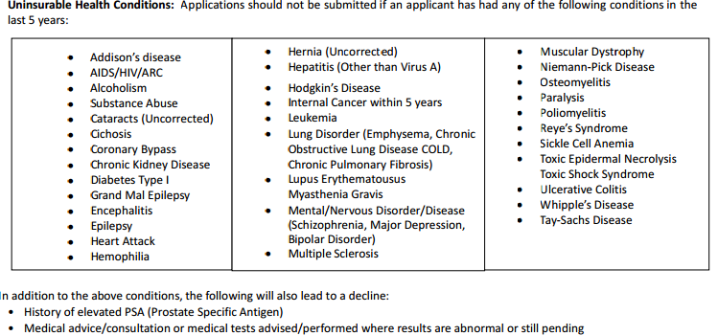

- Can Central Choice & Affordable Choice be bundled? No

- How is previous Limited Benefit coverage being verified? The client would answer “yes” to this question on the application; provide previous company name, policy number & coverage type.

- Do network discounts apply to pre-existing conditions during the first 12mos? ML will re-price all claims, so if network savings they will be applied to the claim once received.

- If someone receives services that are not on the list of covered expenses will network discounts apply? Yes, re-pricing will be done once the claim is received.

- How does a client cancel their ML plan? Recommended method is to complete & fax (or mail) the Health Cancellation form (found in LM or agent /member online portal). Client can also call member services at 800-999-2971.

- Are child only plans available? Yes-ages 0 to age 17. (as long as they’ve had their Well Baby check up) The oldest child would need to be listed as the primary.

- How can missing application information be provided to ML/Viva Life? The client can send an email response or call into member svcs.
- What’s the best way for the agents to get decline/late payment info on their book of business? In the agents back office under their INFORCE BUSINESS(see screen shots below)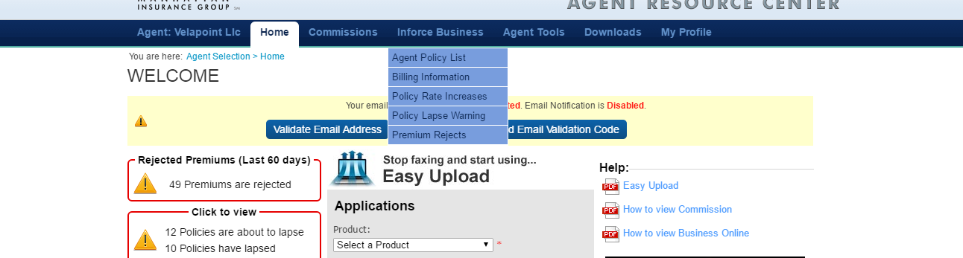
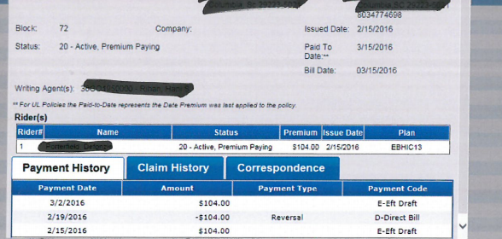

- Can a client access their own policy? Yes. The client can access their own policy materials by: logging in to manhattanlife.com under policy holder center & creating a log in & password.
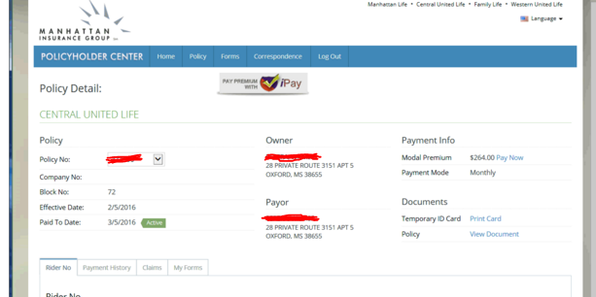

- Can a client pay their bills online or make billing changes online? Yes, otherwise they will have to submit a EFT/CC change form.

- If a policy terminates does the client get notice? Yes. And the agent has access this letter & all other correspondence that goes out to the client in their back office under In force Business.
