1. Are marketing brochures available? No
2. Who can MEMBERS contact for Starmount inquiries or plan changes? 888-400-9304 or Oneplus@alwayscarebenefits.com
3. Who can the AGENTS contact for Starmount inquiries?

[individualsales@starmountlife.com](mailto:individualsales@starmountlife.com) or 800-294-0432.

1. Can you have more than one Starmount policy? NO
2. Does Starmount dental work like Assurant where they can use the Starmount in addition to other dental plans?  If an individual has coverage with another carrier, our plan will coordinate benefits.
3. If a dentist does not come up in the dentist locator can they still use the PPO dental plan or would it be best to use the scheduled plan? With the PPO plans members can choose any dentist but if they do elect to go out-of-network, they could be balanced billed as we are only going to pay based on the in-network provider negotiated discounted rate for that area.  If the out-of-network provider’s rates are higher, the member will be responsible for the difference.
4. Do the “scheduled plans” pay according to the schedule regardless of dentist being in or out of network?  Yes
5. What does the “No Wait” plan mean? Client can pay extra for this plan & bypass the 12months waiting period for “Other services” described in detail on the brochure.
6. What is needed in order to qualify for a “No Wait” plan? To qualify, you must have been enrolled in a plan with similar coverage within 63 days of your application date. Proof of similar coverage, with coverage for major services, is required to be submitted within 30 days of your effective date. Discount dental plans do not apply. Starmount will make several attempts to contact the client for this information if it is not received.
7. What qualifies as proof of prior coverage? We can accept a letter of credible coverage from the carrier, a copy of the policy or policy dec sheet that describes the benefits offered, copy of benefit summary if group coverage, a copy of the ID card if it outlines the benefits.

The following is required in whatever proof is sent:

* Name of previous insurance company
* Member No. or Group No.
* If Group, employers name the insurance was under
* Effective and termination date of coverage
* Description of services reflecting that major services were covered i.e. bridges, crowns, dentures etc.

Email proof to [oneplus@alwayscarebenefits.com](mailto:oneplus@alwayscarebenefits.com) or fax 855-400-9309.

1. How does a draft show on bank statement: Starmount Life – Always care
2. When will the client acct be drafted?

Initial Draft: At time of policy submission.

Subsequent Drafts:

Credit cards:  Charged on the 5th of each month

Bankdrafts:   Drafted between 2nd & 10th of the month (if declined a double draft will be attempted the prior month)

1. Where can I see my back office information? Under the “Producer” tab at the top of your Starmount webpage, at the bottom you will see this:

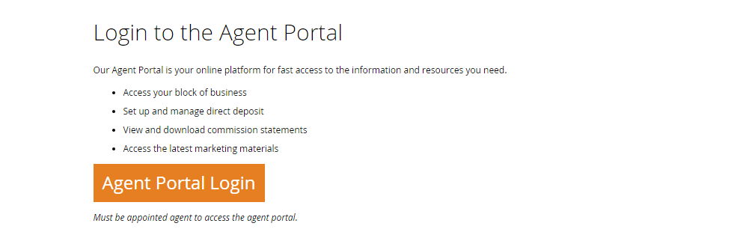

1. Can we send the client a link showing plan options? Yes, the agents link is a custom link & can be sent to the client at anytime for them to complete & submit & the agent will receive credit. The link can also be customized to only show specific plan options.
2. Client materials (including copy of ID card):  utilize [www.alwaysassist.com](http://www.alwaysassist.com/) & set up 'new member registration' using their IDN # that's also provided when you sign them up. In this site they can print ID cards, search dentists, search procedural costs & view EOB's, etc.
3. Are Group sales available through Starmount? Yes. Contact Jennifer Mulqueen for additional information.
4. Is child only available? Yes in select states only : GA, IN, LA, MO, MS, NC, OH, SC, TX, & WI. Children 19 & Under. (These are the QDP’s that the family can also be added to).
5. Eff date rules:

Submitted 1st-25th =1st of the next month

Submitted 26th-31st=1st of the following month

*\*\*Ex. Submitted 8/24=eff date 9/1*

*Submitted 8/28=eff date 10/1*

1. How can a Starmount plan be canceled? Contact member services via email:Oneplus@alwayscarebenefits.com or call member services; 888-400-9304
2. Is List Bill Option Available? Yes.  For set up, call the Starmount team at 800-294-0432.  They will send the data sheet to complete & will to know if they want to have the employees submit the applications via paper or custom link.   If custom link, we will issue the link and send to the agent.